**Admission_Prediction**

**Data Info:**

RangeIndex: 500 entries, 0 to 499

Data columns (total 9 columns):

# Column Non-Null Count Dtype

--- ------ -------------- -----

0 Serial No. 500 non-null int64

1 GRE Score 485 non-null float64

2 TOEFL Score 490 non-null float64

3 University Rating 485 non-null float64

4 SOP 500 non-null float64

5 LOR 500 non-null float64

6 CGPA 500 non-null float64

7 Research 500 non-null int64

8 Chance of Admit 500 non-null float64

dtypes: float64(7), int64(2)

memory usage: 35.3 KB

**Nan:**

Serial No. 0

GRE Score 15

TOEFL Score 10

University Rating 15

SOP 0

LOR 0

CGPA 0

Research 0

Chance of Admit 0

dtype: int64

**Describe():  
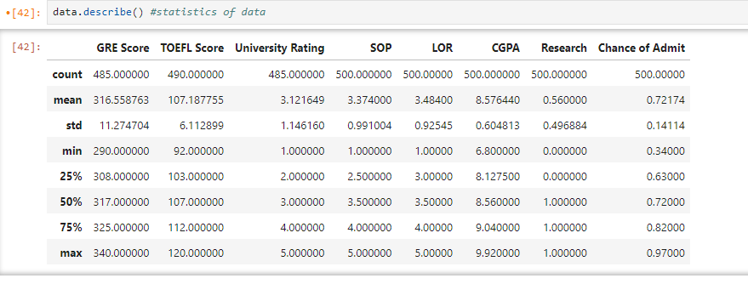**

**After Filling NAN:**

**Describe:**

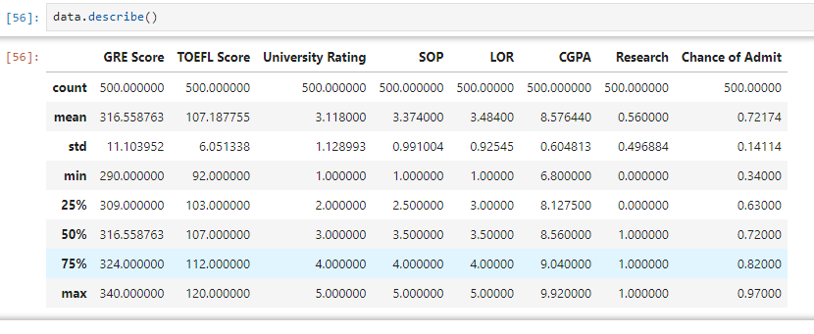Continuous data column

* GRE Score
* TOEFL Score
* CGPA

Discrete data column

* University Rating
* SOP
* LOR
* Research

Label Column

* Chance of Admit